

GROUP MEMBERS :

Student1496959 MUHAMMAD SAMI

Student1505922 SYED ABDUL RAFAY

Student1505778 HARIS RASHEED

Contents:

***CERTIFICATE OF COMPLETION*** 4

**ACKNOWLEDGEMENT** 5

**PROJECT SYNOPSIS** 6

***PROPOSED SYSYTEM:*** 7

***FLOWCHART:*** 8

8

***Functional Requirement*** 9

***Problem Statement:*** 10

***Hardware and Software Requirements*** 11

**Hardware** 11

**Software** 11

***Website Features*** 12

**USER’S GUIDE** 13

**HOMEPAGE(landing page)** 13

**CONTACT US** 13

**ABOUT US** 14

**SLIDES** 14

**GALLERY** 16

16

**FOUNDATION** 16

**SAFETY COMES FIRST** 17

**OTHER FACILITIES** 17

Lockers 17

Separate Pools 18

Restrooms And Changing Areas 18

18

**FOOD ZONE** 19

**LOCATION MAP** 20

DEVELOPER’S GUIDE 20

CDN’s: 20

FOOD ZONE: 21

OTHER FACILITIES: 21

GALLERY: 22

We have given section there contains nine images of slides. 22

CONTACT US: 22

LOCATION: 22

**CERTIFICATE OF COMPLETION**

This is to clarify that MUHAMMAD SAMI, SYED ABDUL RAFAY AND HARIS RASHEED have successfully completed their ACCP Semester 1 E-Project.

Submitted to Aptech Computer Education on

February 13, 2024

**acknowledgement**

First of all we would like to thank Almighty Allah for giving us strength and ability to complete this project.

And then, we would like to express our special thanks of gratitude to our teacher **Sir Tipu shafique** who guided us on the project *LIBERTY ELECTRONICS*, which also helped us in doing a lot of new learning and we came to know about so many new things we are really thankful to him.

We are highly thankful to **Sir Tipu shafique** for his guidance and constant supervision as well as for providing necessary information regarding the project & also for his support in completing the project.

We earnestly hope that this project will provide all the necessary information required by the user to fulfill his/her inspiration. However, suggestion and Feedbacks for improvements will be thankfully welcomed & acknowledged*.*

**PROJECT SYNOPSIS**

**PROPOSED SYSTEM**

**FLOW CHART**

**LIBERTY ELECTRONICS**

**FUNCTIONAL REQUIREMENT**

**PROBLEM STATEMENT**

**HARDWARE AND SOFTWARE REQUIREMENT**

**WEBSITE FEATURES**

**USER’S GUIDE**

HOME PAGE:



**USER’S GUIDE**

LOGIN PAGE:

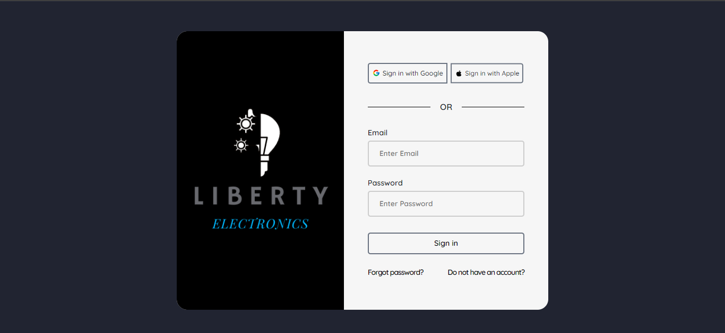

**USER’S GUIDE**

CART PAGE:

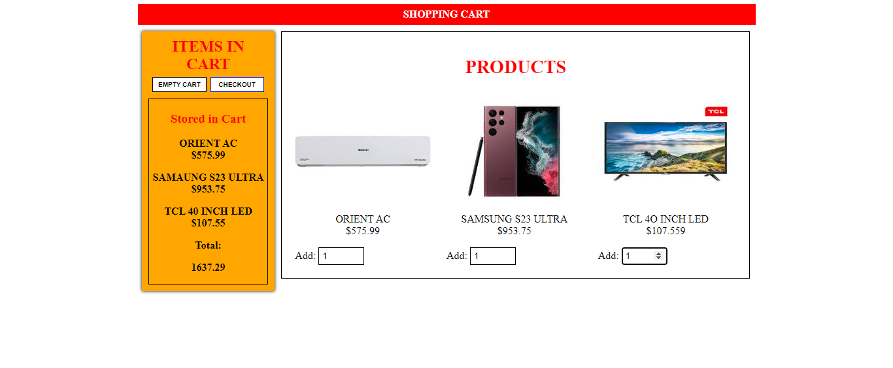

**USER’S GUIDE**

NAVBAR PRODUCT DROP DOWN:

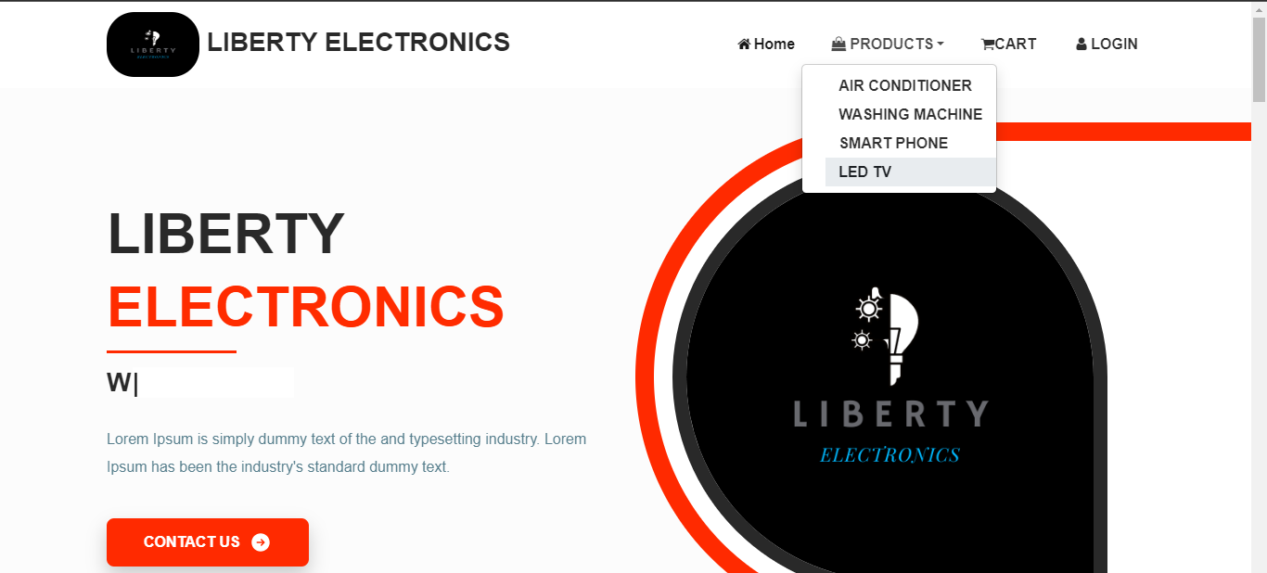

**USER’S GUIDE**

SLIDERS:

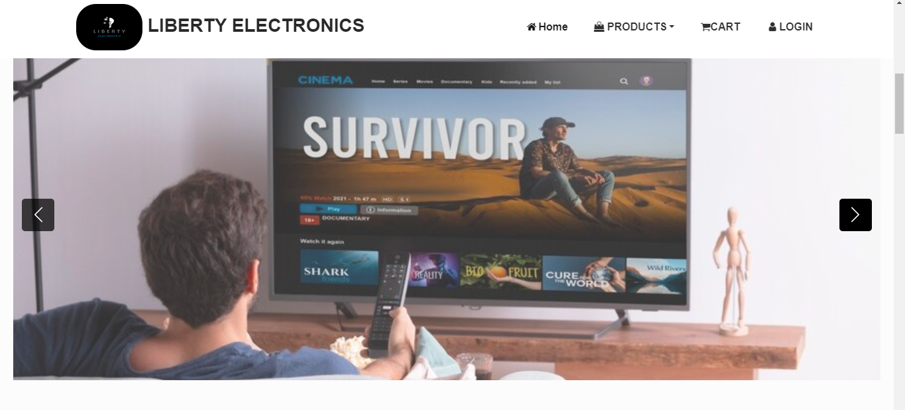

**USER’S GUIDE:**

BRANDS CARDS:

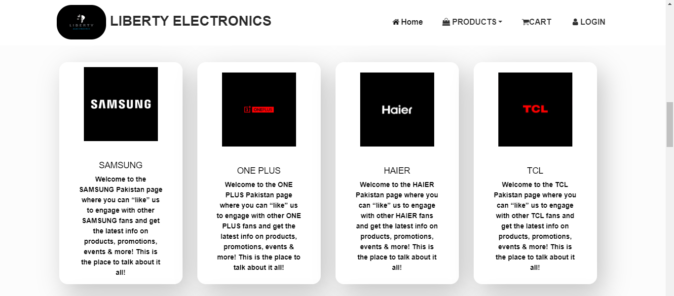

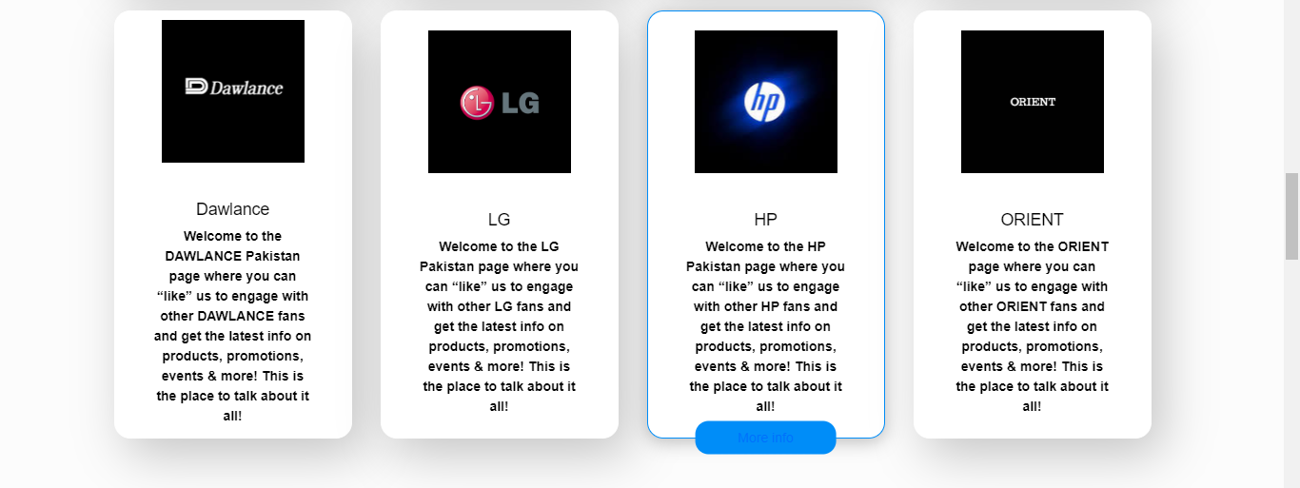

**USER’S GUIDE**

CONTACT US:



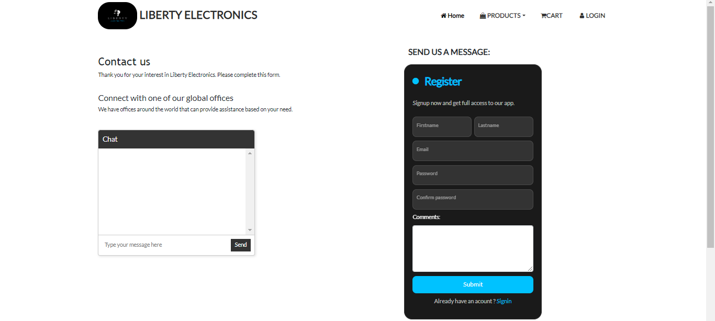

**USER’S GUIDE**

IMAGE EFFECT:

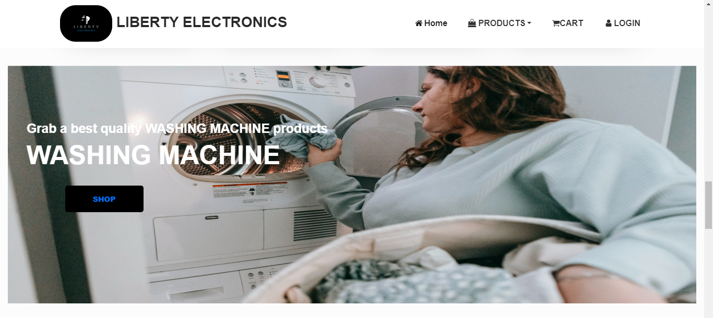

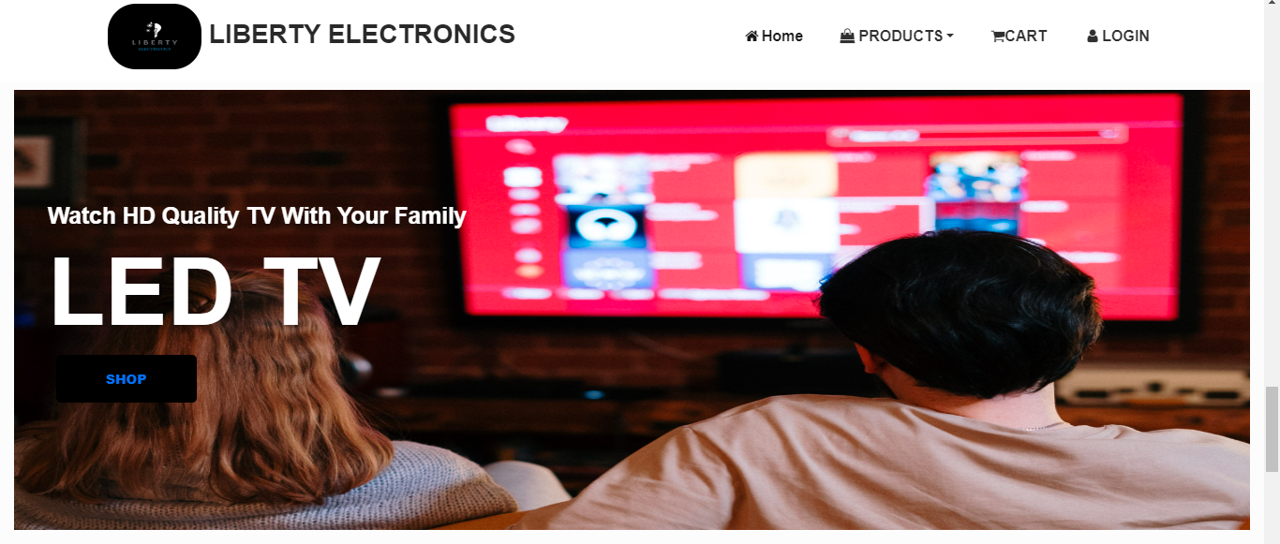

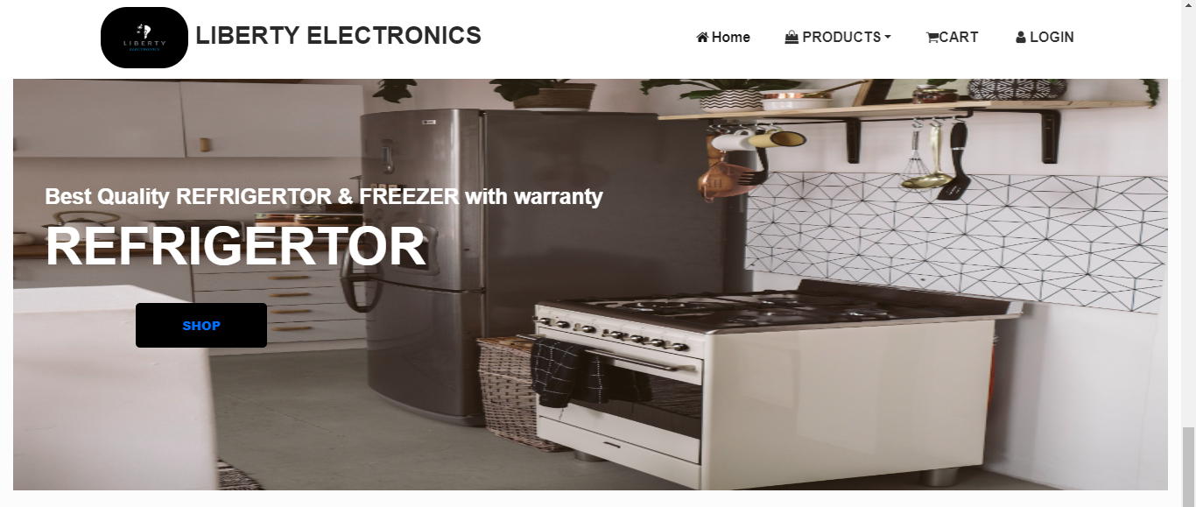

**USER’S GUIDE**

SAMSUNG PRODUCTS:

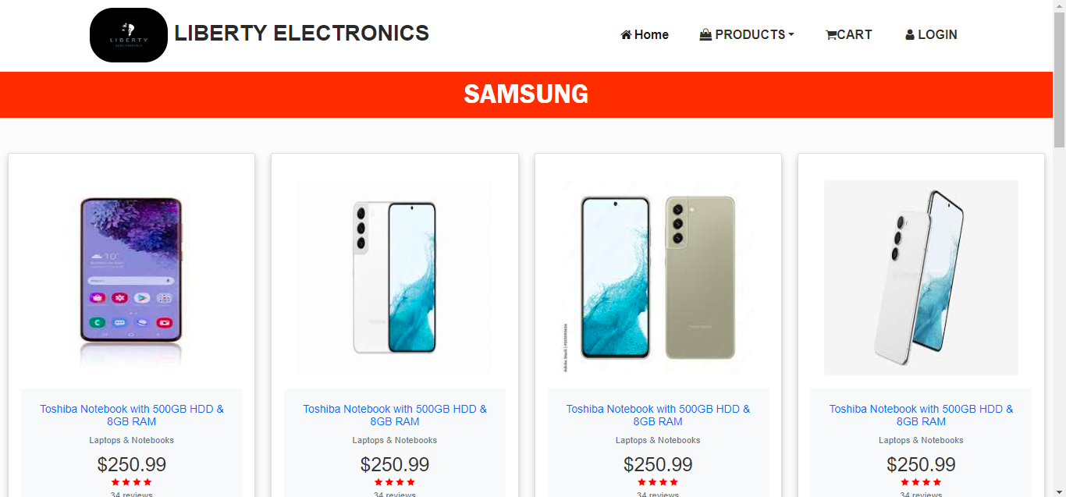

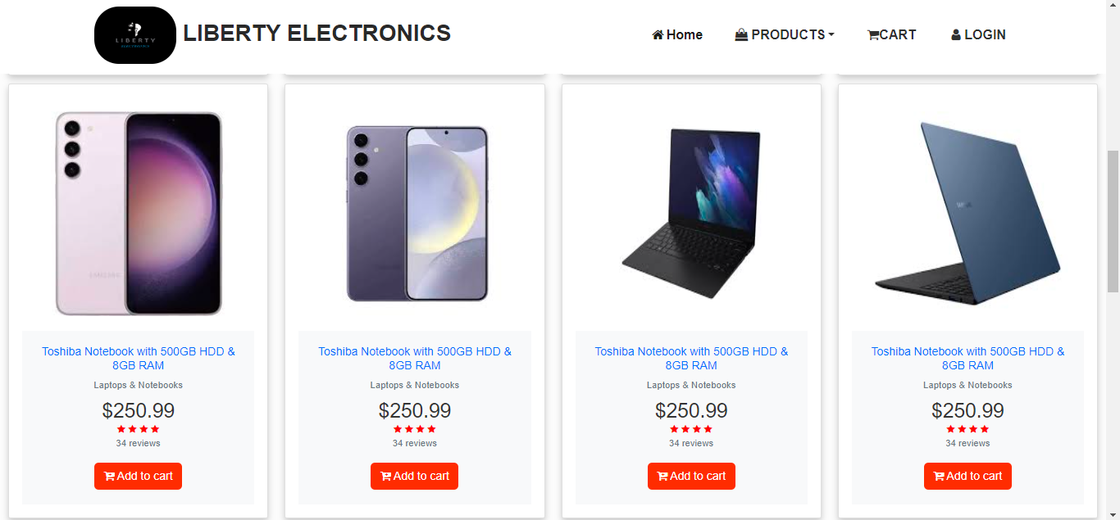

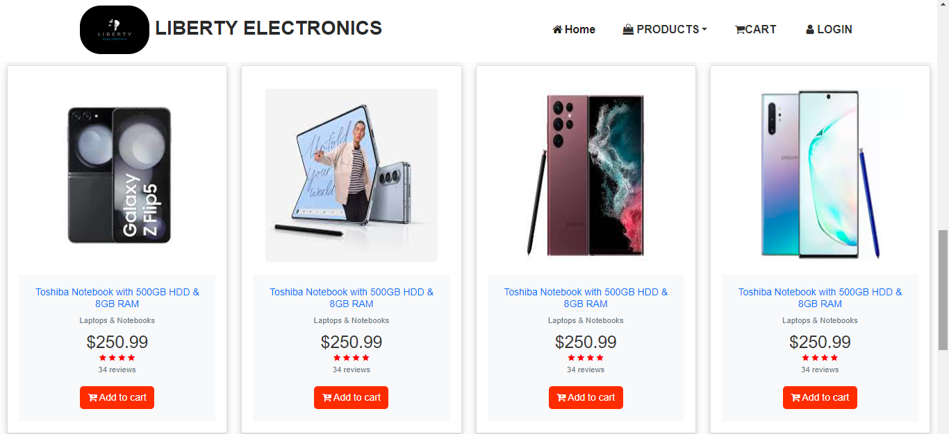

**user’s guide**

ONE PLUS PRODUCTS:

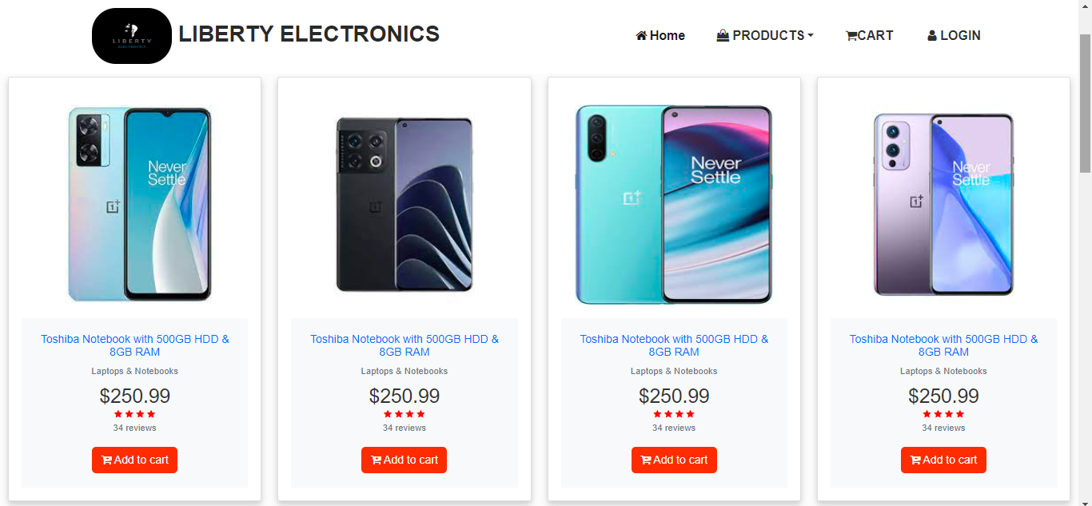

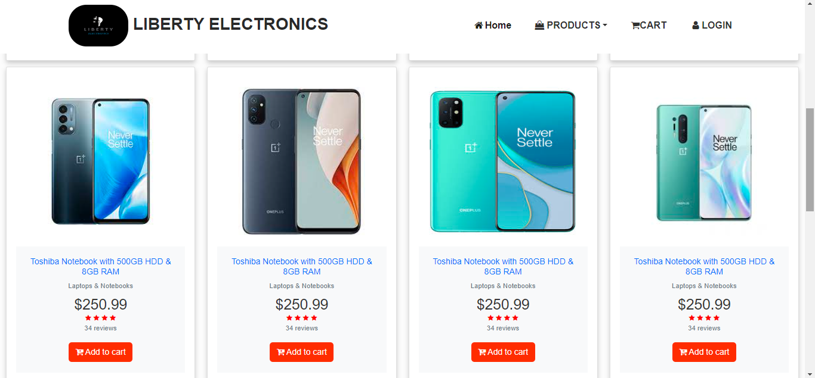

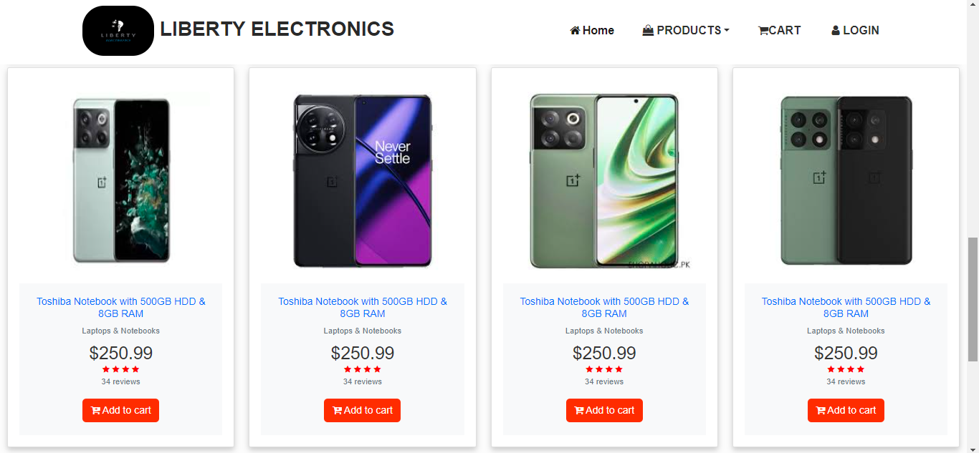

**USER’S GUIDE**

HAIER PRODUCTS:

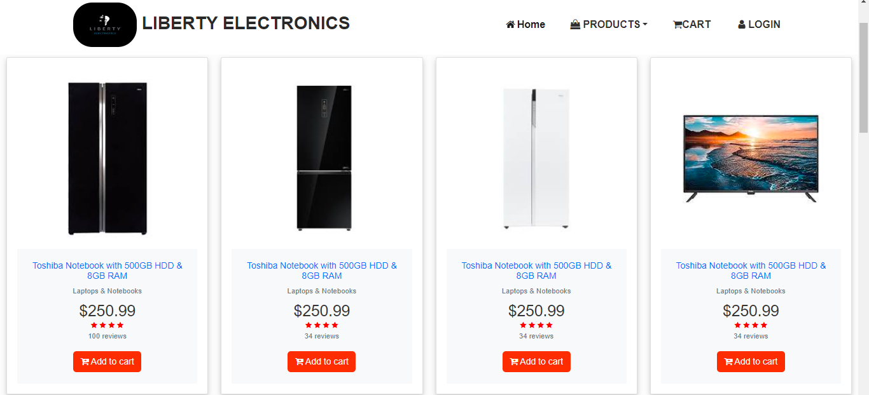

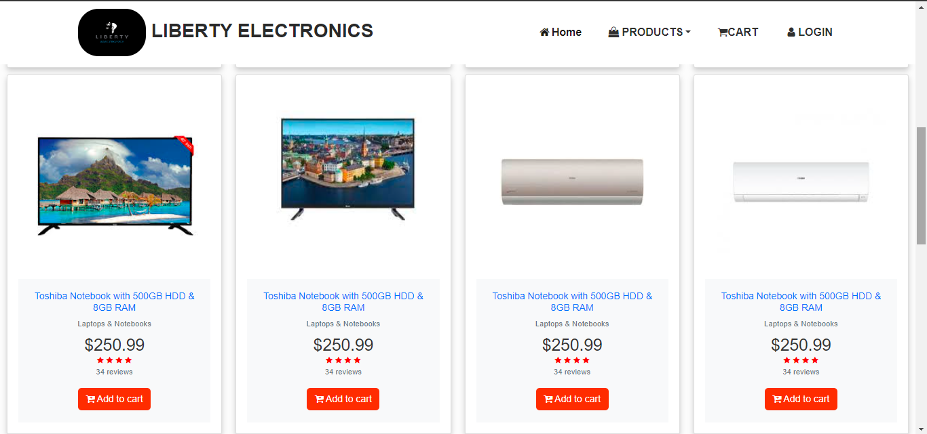

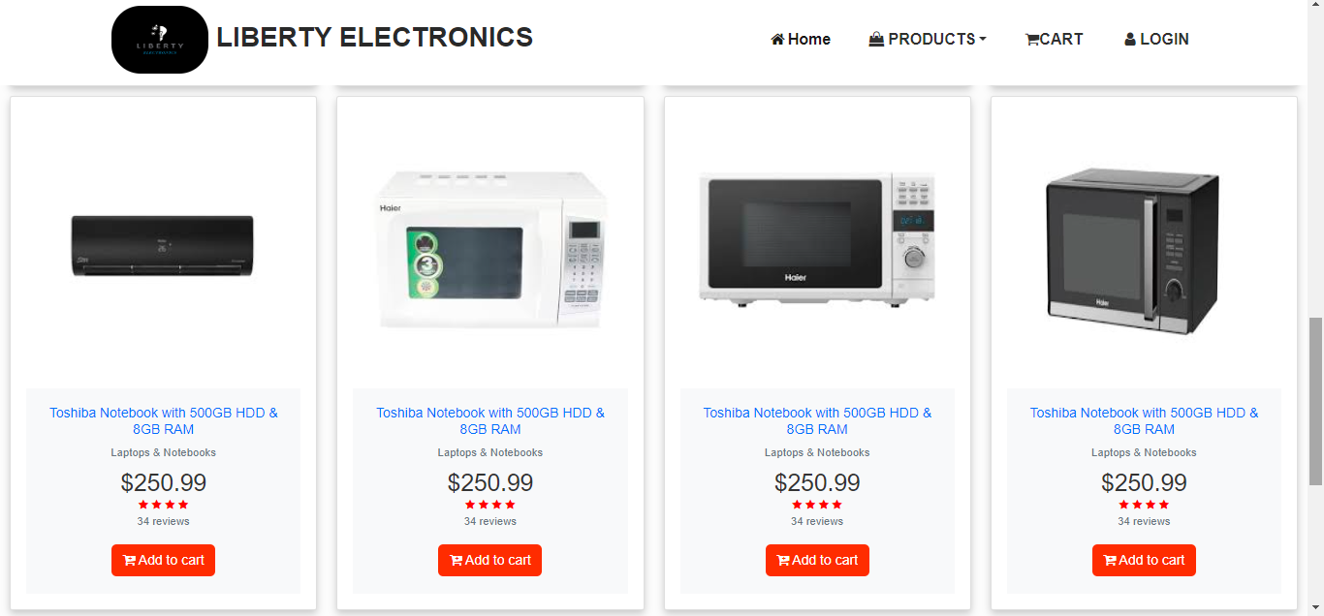

**USER’S GUIDE**

TCL PRODUCTS:

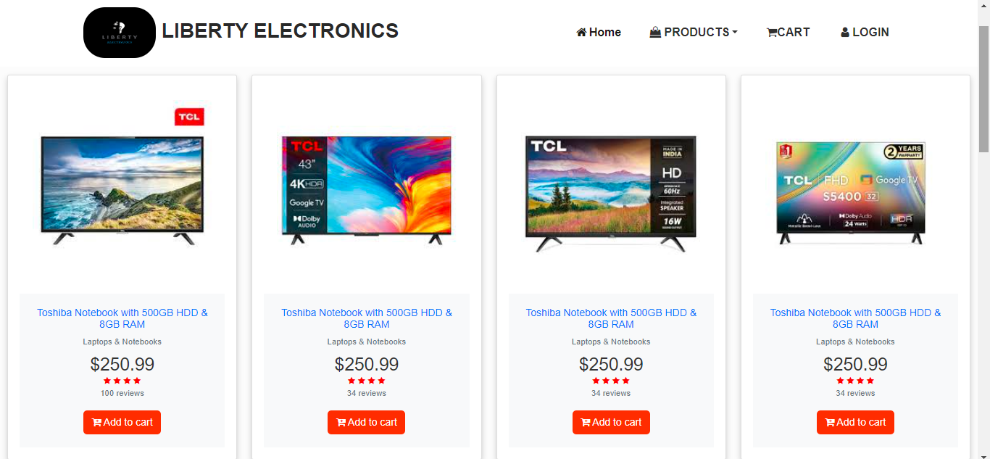

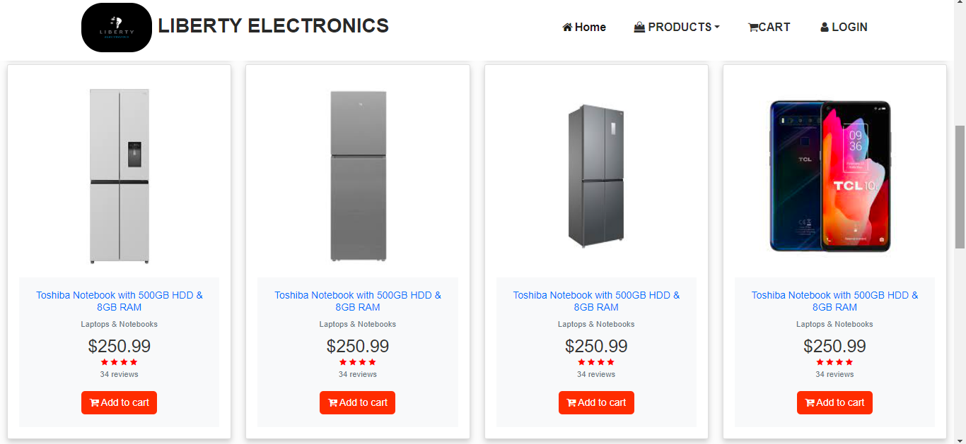

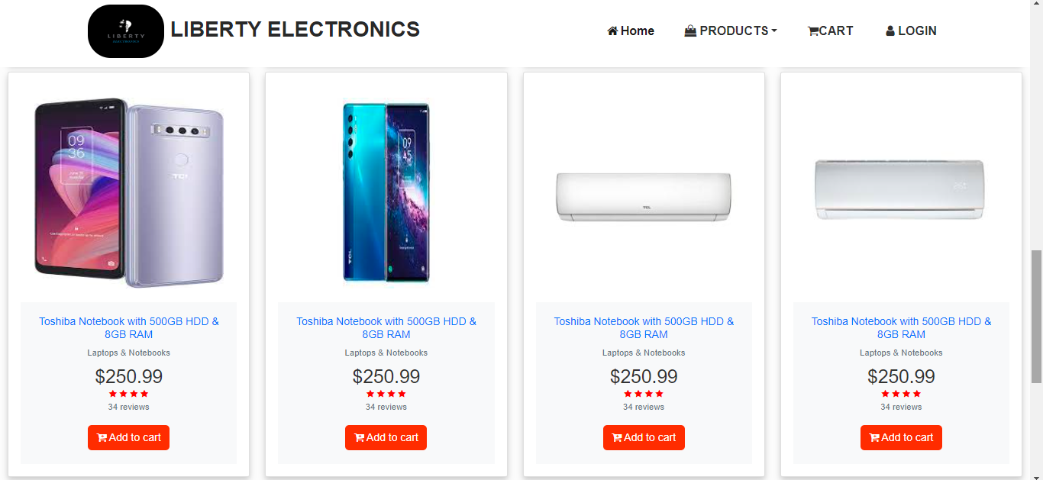

**USER’S GUIDE**

DAWLANCE PRODUCTS:

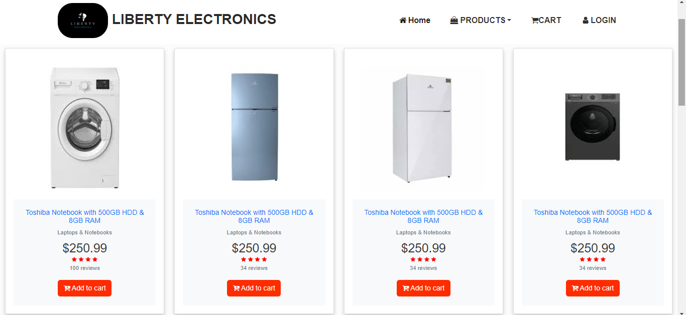

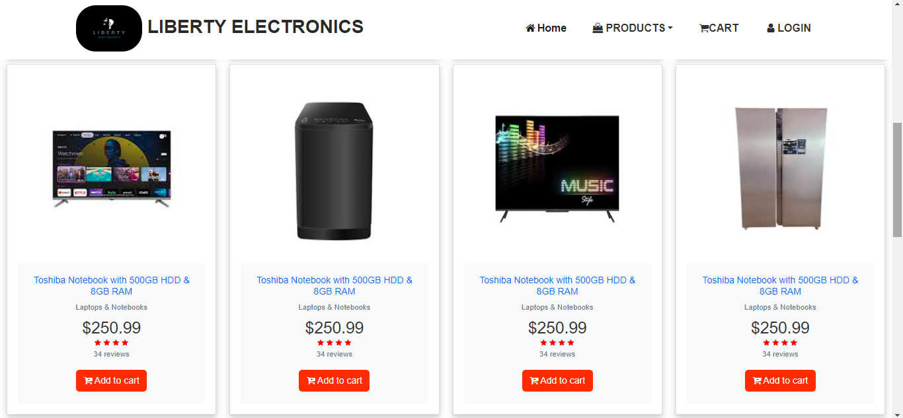

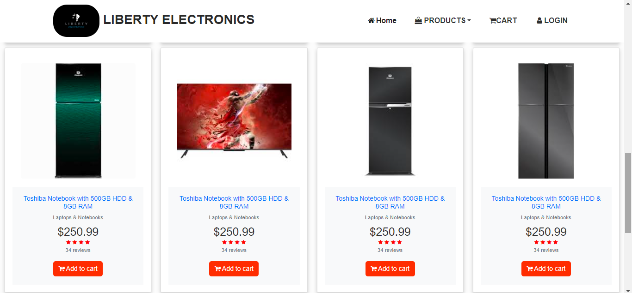

**user’s guide**

LG PRODUCTS: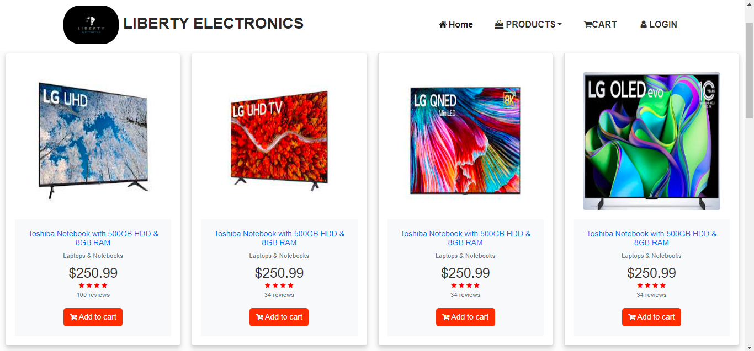

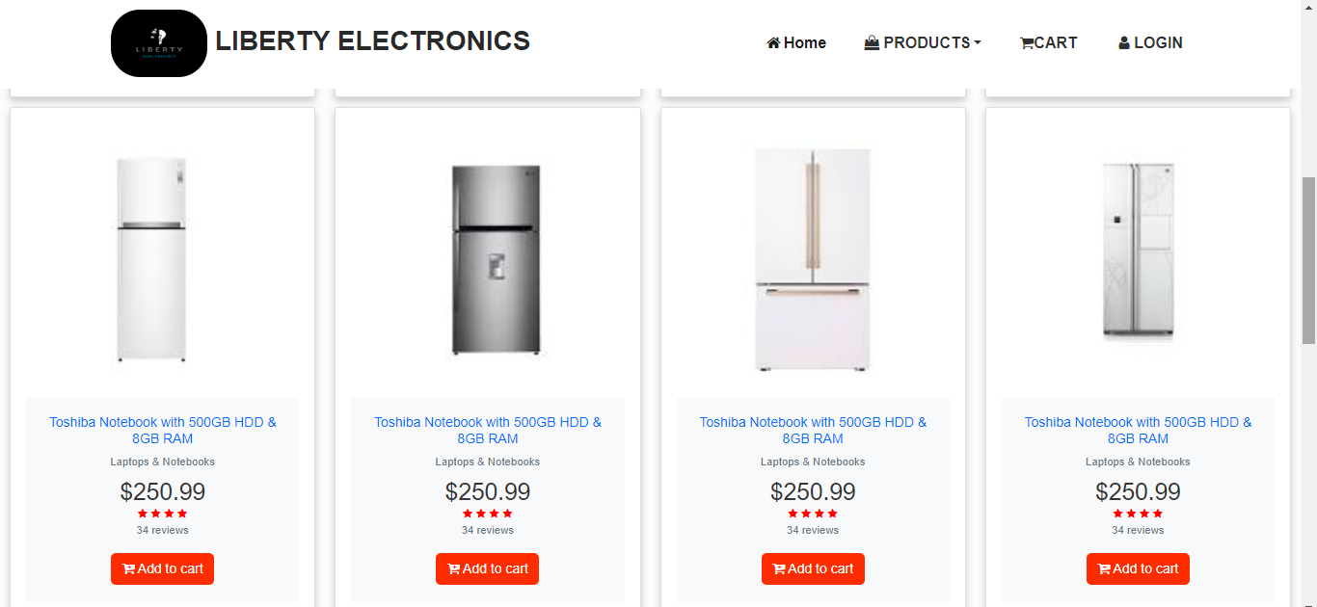

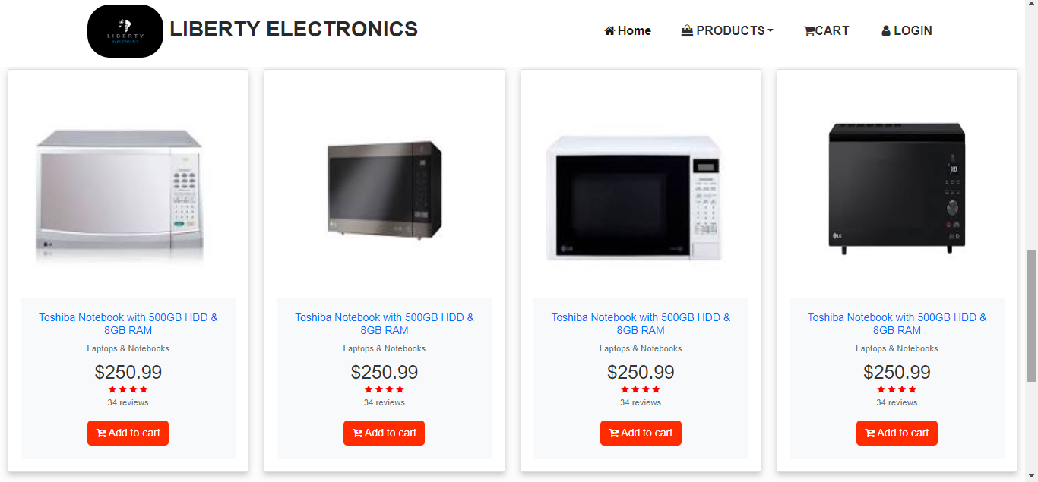

**USER’S GUIDE**

HP PRODUCTS: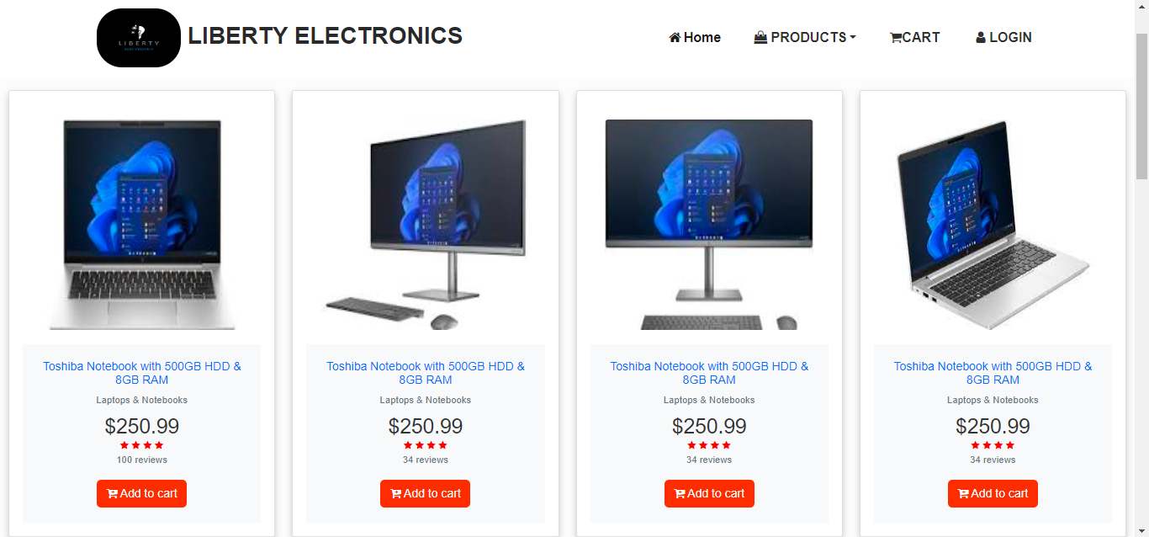

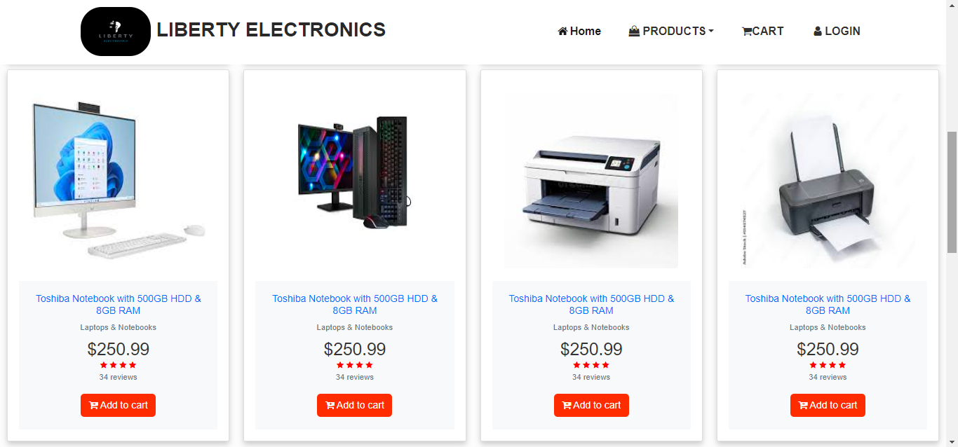

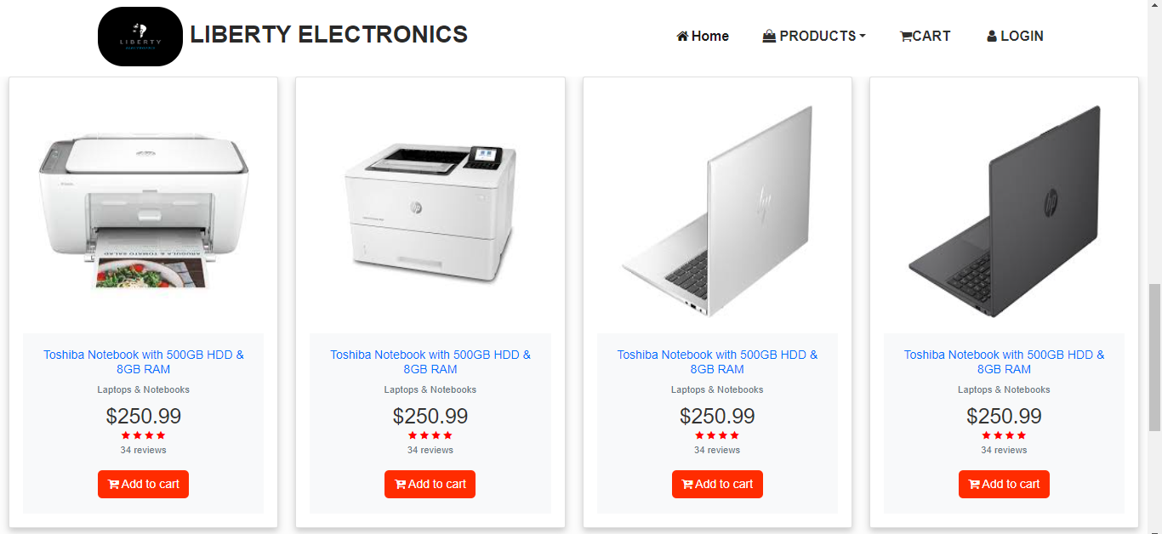

**USER’S GUIDE**

ORIENT PRODUCTS:

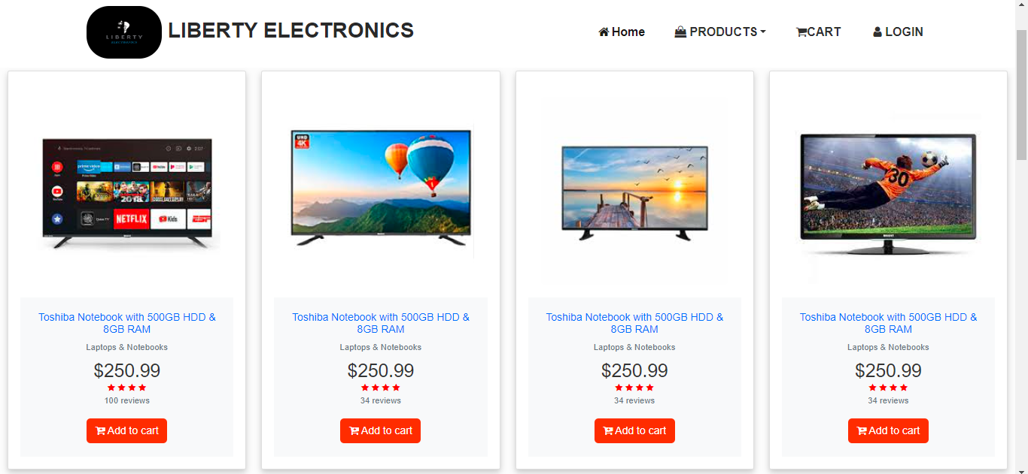

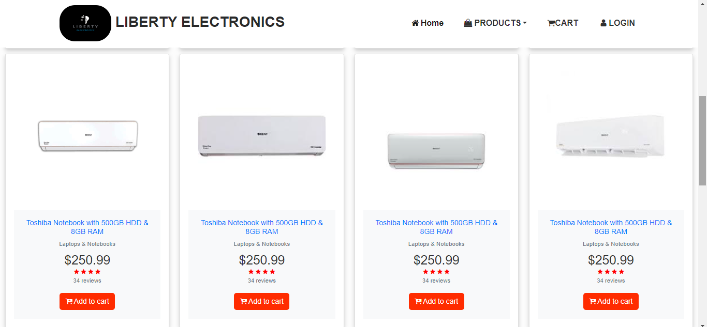

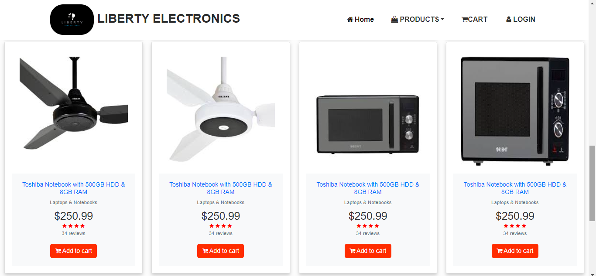

**USER’S GUIDE**

DROP DOWN

AIR CONDITIONER: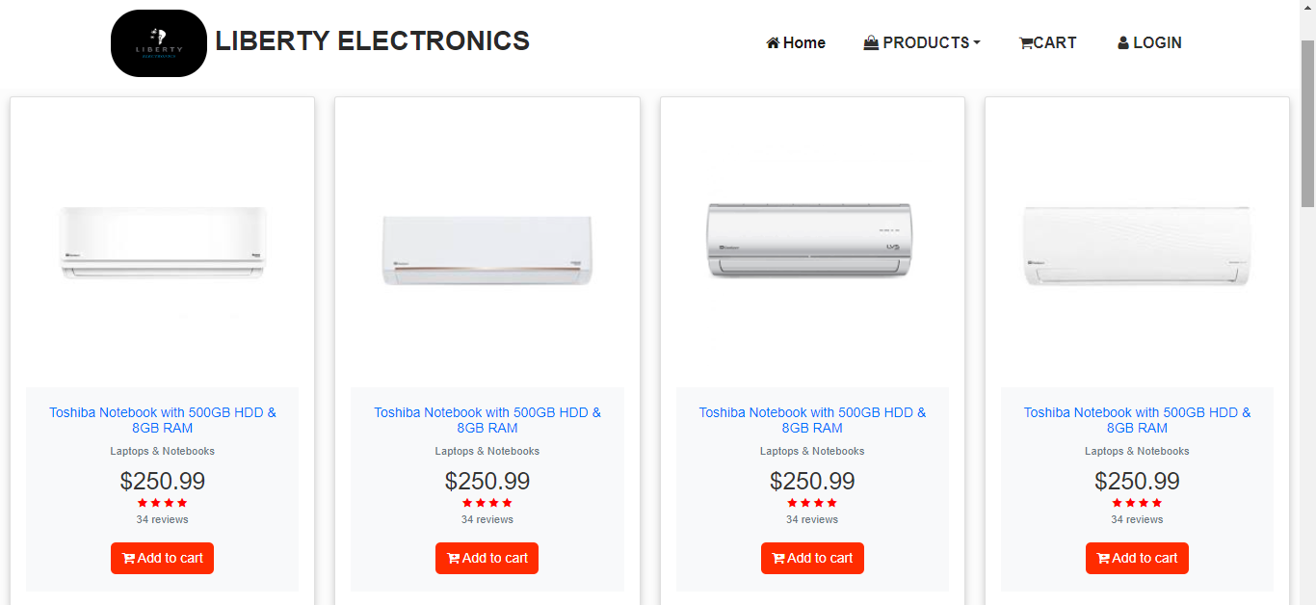

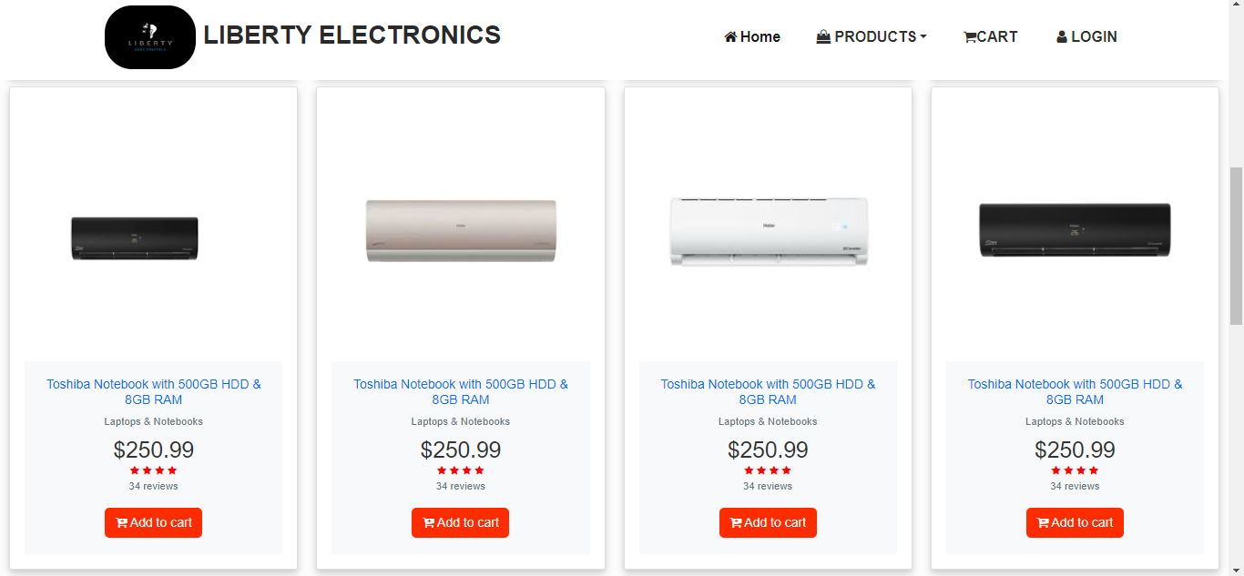

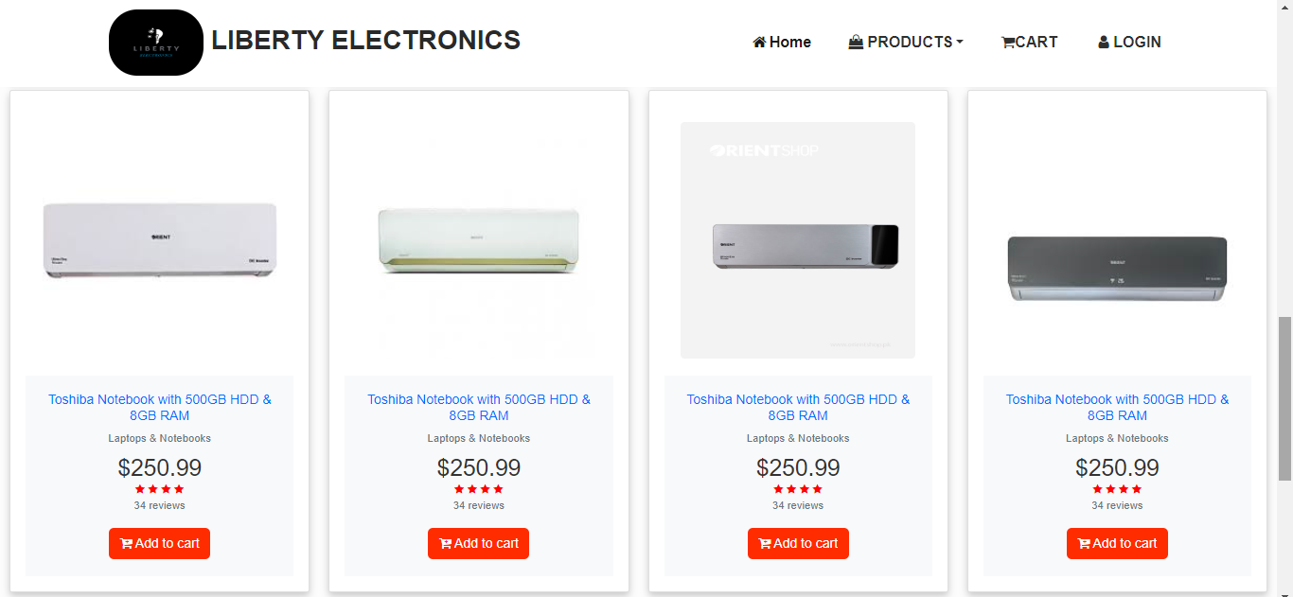

**USER’S GUIDE**

DROP DOWN

WASHING MACHINE: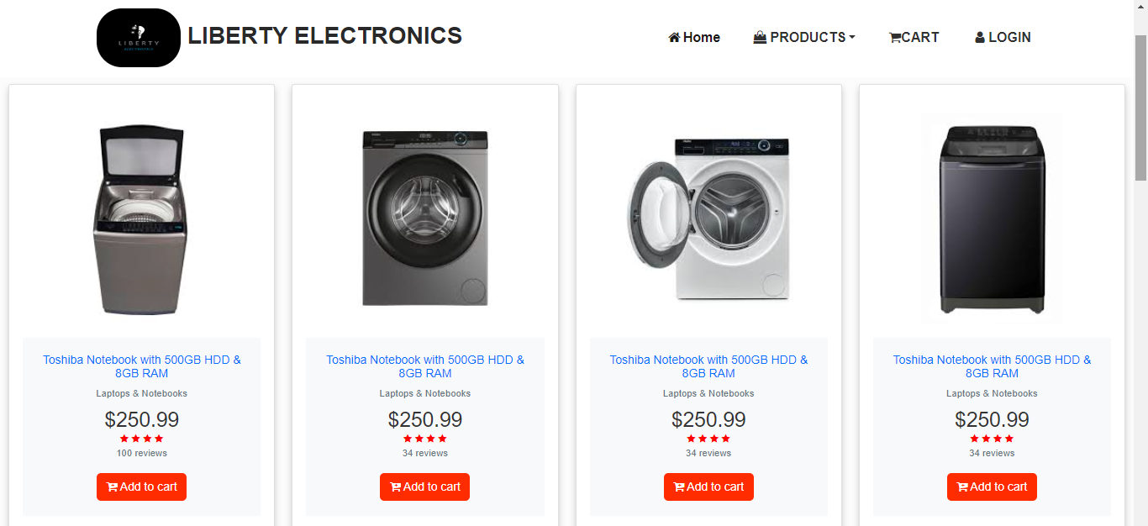

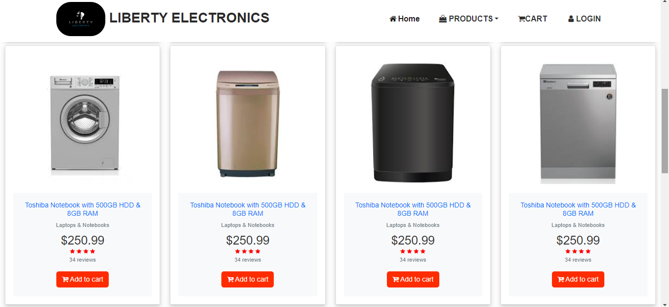

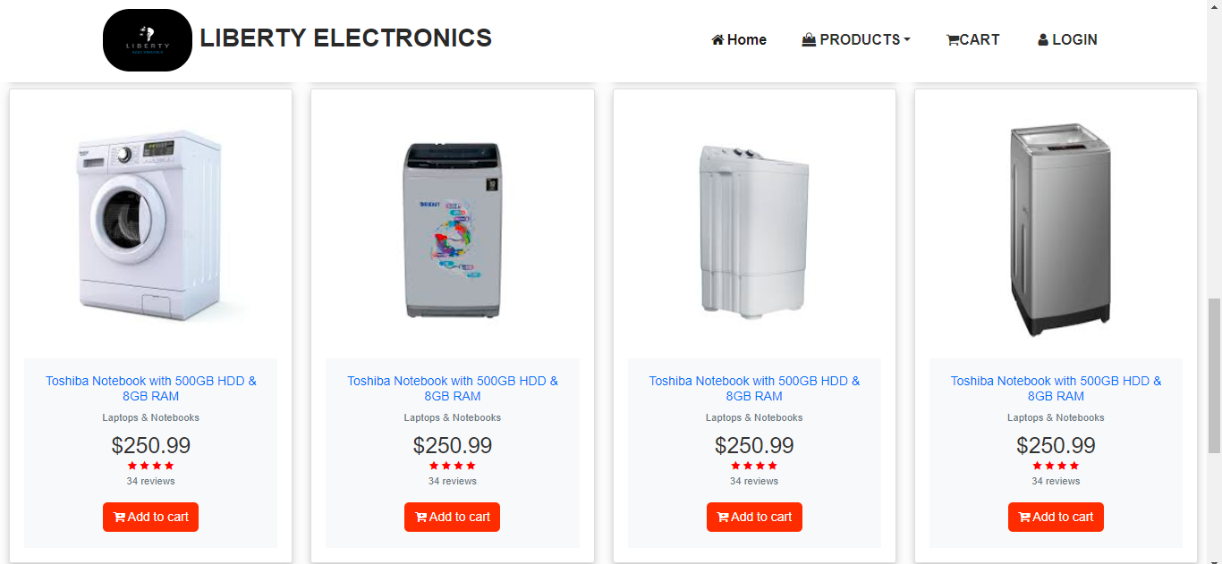

**USER’S GUIDE**

DROP DOWN

SMART PHONE: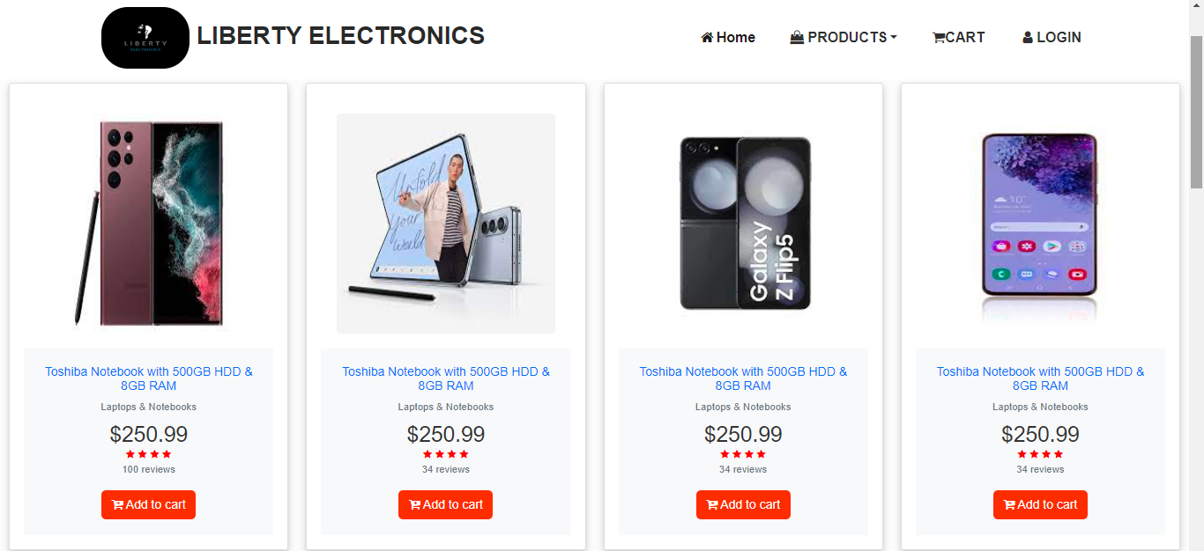

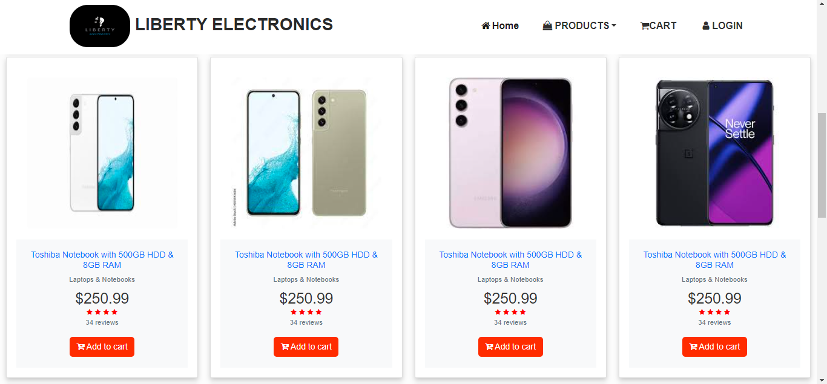

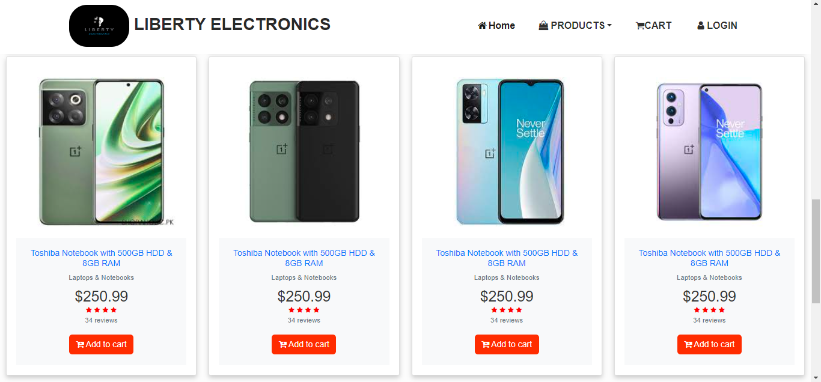

**USER’S GUIDE**

DROP DOWN

LED TV: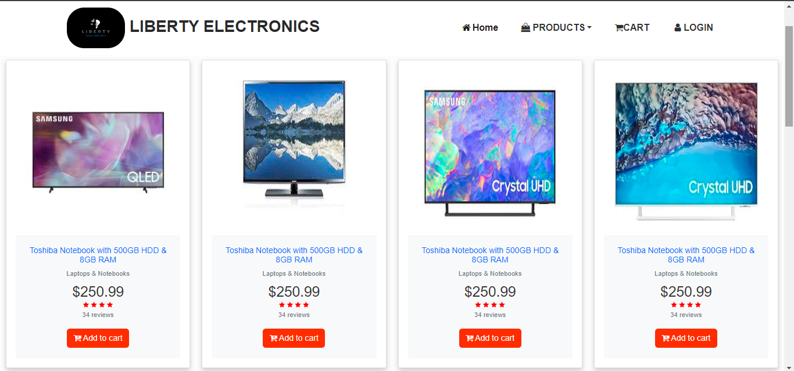

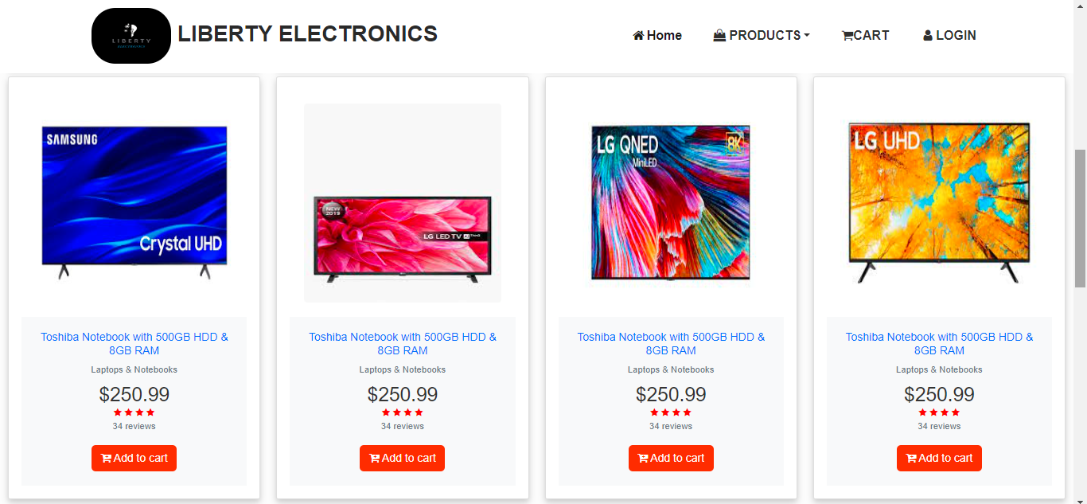

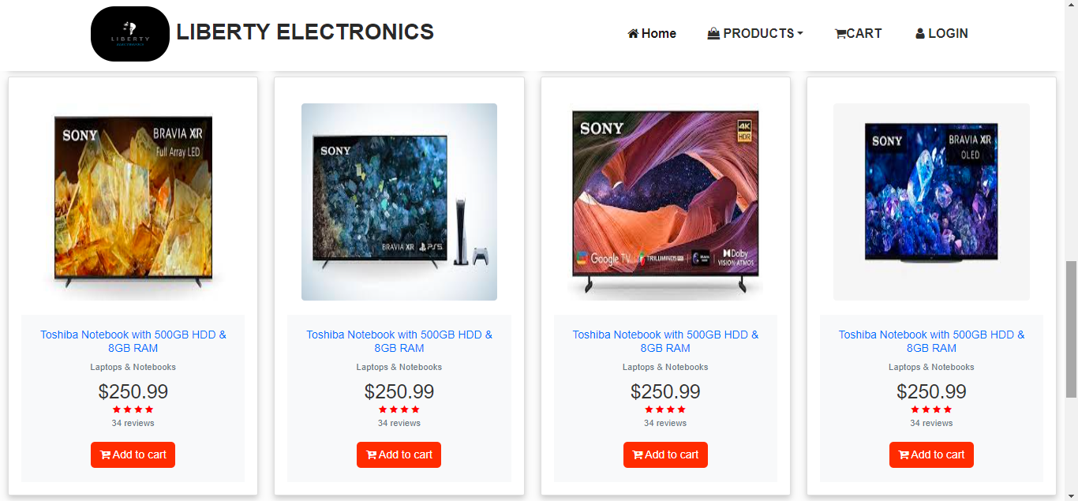

**user’s guide**

FOOTER:

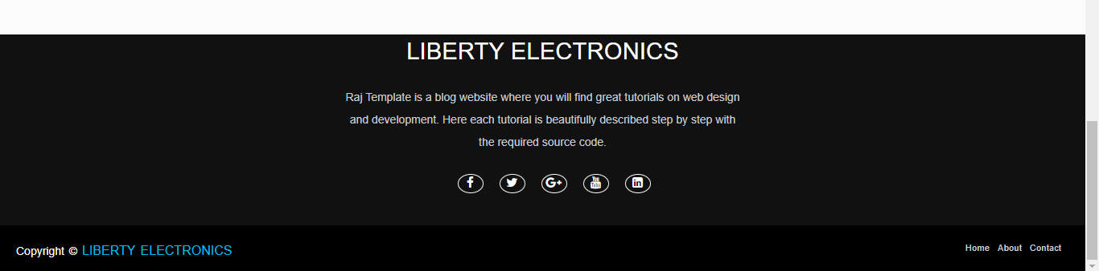

**DEVELOPERS GUIDE**

We needed to develop a website of electronics named LIBERTY ELECTRONICS. This is a guide for developers on how this website has been created and everything the next developer needs to know to make changes or study the website.

## CDN’s:

Almost all of the work has been done using bootstrap 5.

HOMEPAGE (Landing Page):

We have given navbar at the top of the homepage which includes HOME, PRODUCTS, CART, & LOGIN PAGE. Product have dropdown lists. After that we have given banner of website. After that we have given carousel which includes 3 slides. Below the carousel there are 8 cards given those cards given products images and brief information about products, after that we have given a three hover images you will further see the information about each image by clicking on them. After that we give footer.

## 

## CONTACT US:

After navbar we give a banner of website. It contact contain contact us page to contact with website & send products reviews.

BRANDS:

After banner we give 8 brands cards for products.